**Chapter 1**

**INTRODUCTION**

The thyroid cancer has been rapidly increasing. Nowadays, with the awareness of people regarding their health and with the use of advanced ultrasound equipment, in 33% of total populations among the age of 18 and 65 have thyroid nodules. Detection of thyroid nodules has significantly increased over the past two decades with many more nodules now being incidentally detected. As the majority of these nodules are benign or behave indolently, accurate determination of whether thyroid nodules are benign or malignant could reduce patient risk and reduce the significant medical health care costs with Fine Needle Analysis biopsy and/or surgery. One out of ten Indians suffer from Thyroid disorders. This disorder primarily takes place at between the age of 17-54. Identifying the thyroid disorder from the laboratory test report is very complex and requires extensive knowledge and experience, hence using machine learning techniques for this purpose makes the task easier and the results more accurate. Thyroid is butterflying shaped organ with cone like lobes and located in the lower part of the neck below the Adam apple. Thyroid is responsible for functions like metabolism, growth and development of the human body. It releases thyroid hormones into blood stream which helps in functioning of body. image augmentation method based on convolutional network and then evaluate its effectiveness by comparing the final classification results with the dataset augmented by traditional methods. The final classification is realized by transfer learning to fine-tune a pretrained ResNet-18.

**Chapter 2**

**SYSTEM DESIGN**

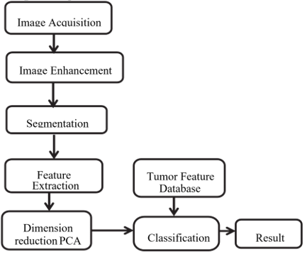

**Fig 2.1: Workflow of Thyroid Nodule Detection**

**2.1 Image Acquisition**

The database consists of ultrasound thyroid images of mixed types like some with cancerous nodules some with noncancerous nodules. Total 65 ultrasound images are used out of which 46 are cancerous or malignant and 19 are non-cancerous or benign. The thyroid images are provided by internet. The format of image used is JPG.

**2.2 Image Enhancement:**

The enhancement provides improved brightness and contrast of image. Techniques like median filtering, Histogram equalization, Global histogram equalization (GHE), Bihistogram equalization (BBHE), Brightness preserving Dynamic fuzzy histogram equalization (BPDHE) and many other are available. Among these BPDHE is used in this proposed work, because it preserves brightness and provides good contrast enhancement. The image histogram is manipulated in such a way that the redistribution of gray level values in valley portion takes place between two consecutive peaks and there is no remapping of histogram. It is implemented by following steps:

* Fuzzy histogram creation.
* Histogram partition.
* Dynamic histogram equalization of partitions.
* Normalization of image brightness.

Thyroid Nodule Detection Using Artificial Neural Network GEC Talakal

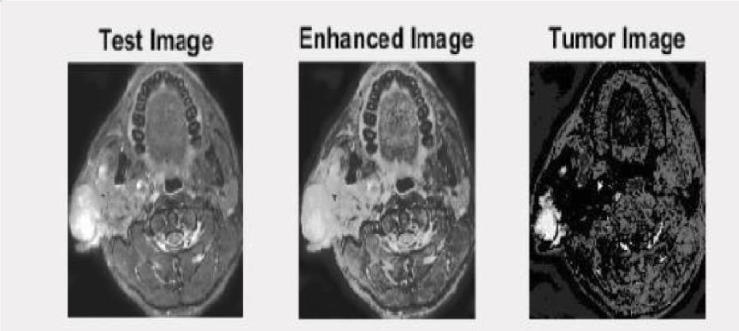

**Fig 2.2: Enhanced Thyroid ultrasound image**

**2.3 Segmentation**

In this proposed work, Snake active contour model is used which works by detecting item in an image by defining beginning curve then it goes on evolving till it reaches and ends on the boundary of the item with following steps:

* The image and σ values for the Gaussian smoothing are chosen.
* The beginning position of the snake is selected by just a click on the image and select control parameters which are then inserted (Spline based) into a curve.
* The different control criterion for snake is specified by user. These include

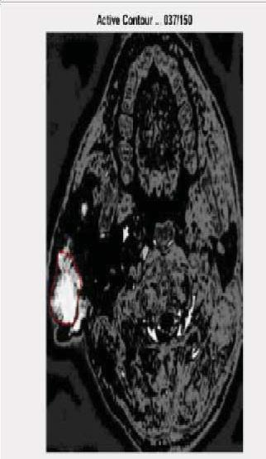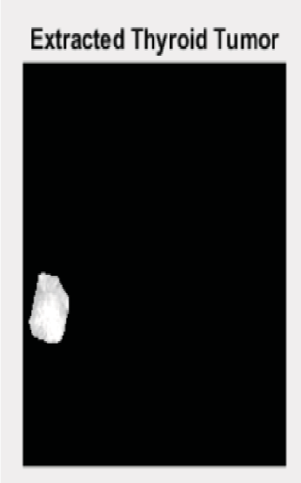

**Fig 2.3: Segmented thyroid nodule**

Thyroid Nodule Detection Using Artificial Neural Network GEC Talakal

**2.4 Feature Extraction:**

Feature extraction is done by extracting some appropriate values from large input data. Classification system is trained using the extracted features. The extracted features must be appropriate to get the accurate and desired output. The feature extraction from the captured images can be carried out different available techniques. Various algorithms and techniques are used by this stage to detect and isolate different portions or shapes of image. These features are defined as follows:

**2.4.1 Statistical features**

The features of the selected ROI are calculated as a feature vector, these include Mean, standard deviation, Variance, Energy and GLCM (Gray Level Cooccurrence Matrix) features.

**2.4.2 Texture Features**

Gabor filters are used to extract texture features which include contrast, homogeneity, energy, correlation. Once the features are determined then using PCA its dimensions are reduced. The features database of all the images is created for classification purpose.

**2.5 Classification**

Classification is a process to determine or identify a category of an object. An algorithm is needed to recognise the correct class. The classifier performance is evaluated by using testing dataset. ANN is a self-learning system and widely used for pattern recognition and classification. It is a parallel distributed processor with natural tendency of storing data. Multilayer perceptron (MLP) by using back-propagation algorithm is used in this proposed work. First feature database of all the known images is built in training phase. These features are uses to train the Neural Network. The features of the testing image are used to classify using trained NN to predict whether the tumour is malignant or benign.

**Chapter 3**

**EXSITING SYSTEM**

The latest molecular tests for cytologically indeterminate thyroid nodules offer varying degrees of risk stratification, but from a clinical management standpoint, test results can be conceptualized into three broad tiers based on probability of cancer

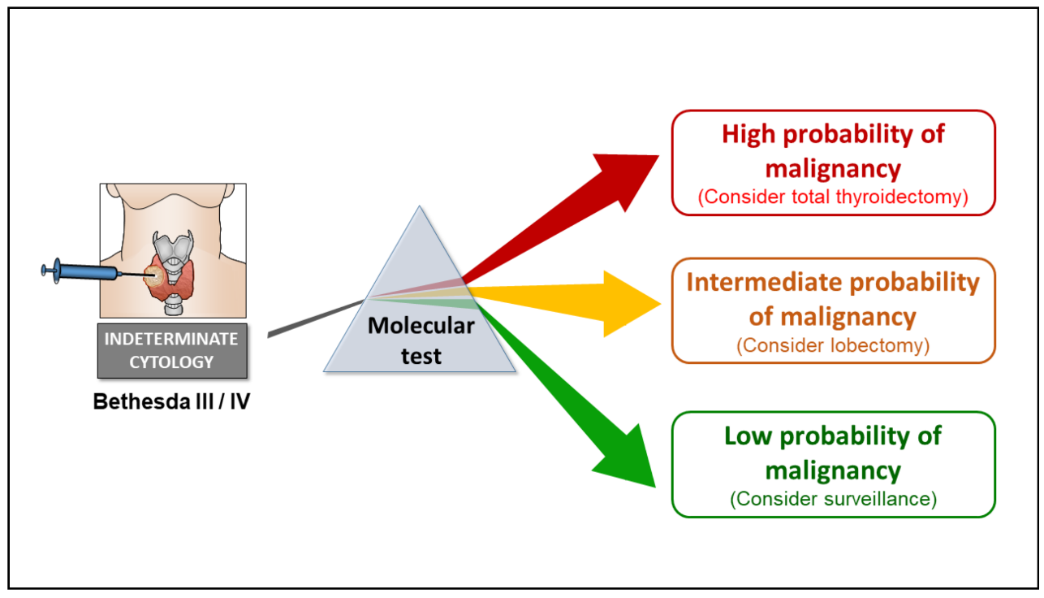

## **Fig 3.1: Molecular Cytologically Indeterminate Thyroid Nodules**

The model illustrating role of molecular testing for refining the cancer risk stratification of cytologically indeterminate thyroid nodules. Current versions of molecular tests described in this review offer varying degrees of risk stratification, but for the most part, test results fall into one of three categories: low, intermediate, or high probability of cancer. A high negative predictive value is a key feature shared by all the tests described herein. Among most cohorts of Bethesda III/IV nodules, a NPV greater than 95% indicates that the cancer risk associated with a negative molecular testing result is less than 5%, similar to that of a cytologically benign nodule.

* High-probability results, where the probability of cancer is so high that thyroidectomy is indicated for therapeutic purposes that the decision between lobectomy versus total thyroidectomy may be informed by clinical, sonographic, cytologic, and molecular features of a nodule.
* Intermediate-probability results, for which a diagnostic lobectomy is recommended for definitive nodule classification and in many cases may suffice from a therapeutic standpoint.
* Low-probability results, where the cancer risk is similar to that of cytologically benign aspirates, for which clinical surveillance would be adequate.

**Chapter 4**

**PROPOSED SYSTEM**

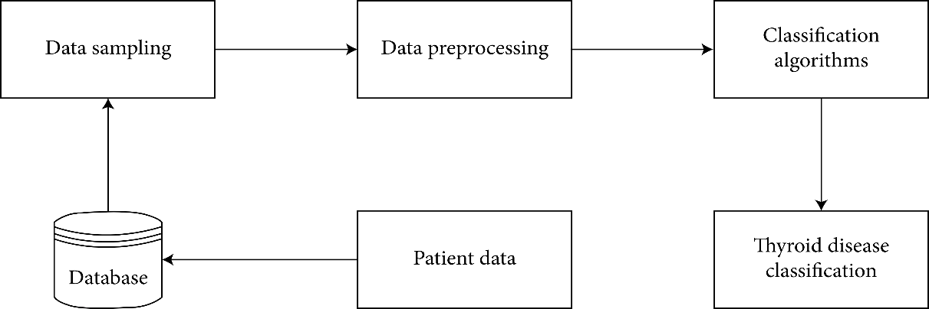

## **Fig 4.1: Proposed System Diagram**

The proposed framework will take input in the form of dataset and then forward to the pre-processing module. In the pre-processing module, the normalization of images is performed in this module. After pre-processing the images, augmentation is performed. In augmentation, the dataset is divided into two parts: the training dataset and the testing dataset. The missing values will be checked in the pre-processing steps. If we detect a missing value, the mean value will replace the value in that column. As the missing value had a data loss of about 91%, that parameter is removed from the dataset. We have adapted the dataset to be better processed with the chosen models.

Feature selection is made to reduce the dimensionality in the dataset. It removes the irrelevant and redundant entries in the dataset. Hence, it increases the accuracy and improves the results. The feature selection identifies the most relevant features for the classification in the classification problems. When raw data is extracted many times, there are missing values in the dataset. The primary demographics contain information regarding the diseased patient’s age, gender, medication, patient condition. The classification will contain two classes. Class 0 is negative, and class 1 is positive. Normal means that the patient is not suffering from thyroid disease.

**Chapter 5**

**IMPLEMENTATION**

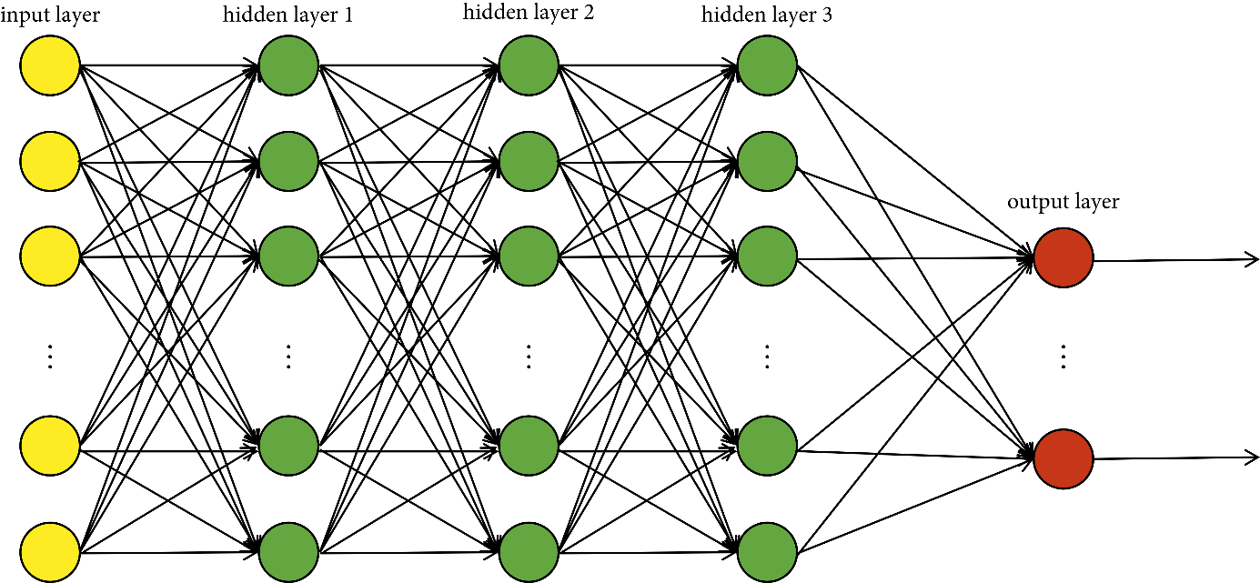

**Fig 5.1: Deep neural networks**

DNN can be trained by back-propagating derivatives of the cost function that measures the discrepancy between the target outputs and the actual outputs produced for each training sample. For the large training sets, it is more efficient to use the strategy of “minibatch” for training deep neural networks model. That is to say, we compute the derivatives on a small, random “minibatch” rather than the whole training set, before updating the weights in proportion to the gradient.

**Chapter 4**

**ADVANTAGES**

* A thyroid ultrasound provides the best information about the shape and structure of nodules
* Doctors may use it to distinguish cysts from solid nodules or to determine if multiple nodules are present
* Doctors may also use it as a guide in performing a fine-needle aspiration biopsy.
* It determines if a lump in the neck is arising from the thyroid or an adjacent structure.
* It analyses the appearance of thyroid nodules and determine if they are the more common benign nodule or if the nodule has features that require a biopsy.

**DISADVANTAGES**

* Problems can occur when a nodule or goiter produces thyroid hormone, leading to an excess amount of the hormone in the body.
* Hyperthyroidism can result in weight loss, muscle weakness, heat intolerance, and anxiousness or irritability

**Chapter 5**

**EXPERIMENTAL VIEW**

The successfully segmented and classified thyroid nodule is shown in below figure

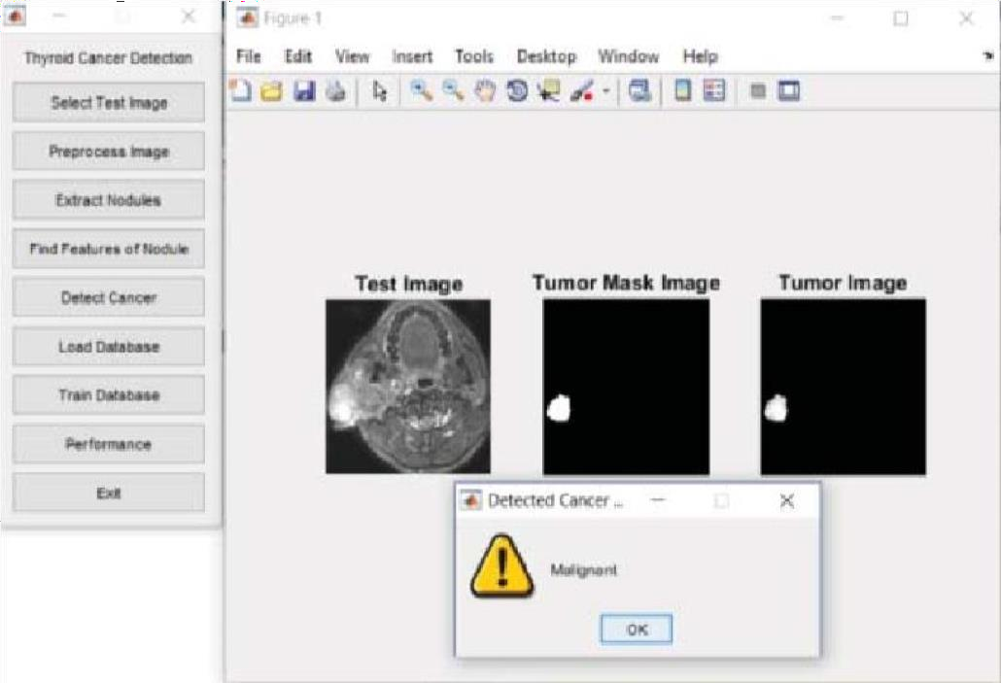

**Fig 5.1: Malignant thyroid nodule**

Theabove experimental view describes that the patient is suffering from Thyroid.

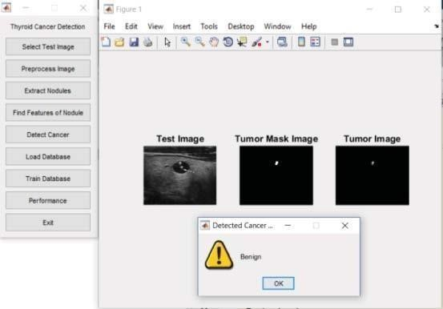

**Fig 5.2: Benign thyroid nodule**

Theabove experimental view describes that the patient is not having Thyroid.